Swanzey Operating Plan
Budget · Forecast · Capital — a consolidated operating reference

PRIVATE working document · v0.1 · June 2026
Built on the Town's own annual reports (2011–2025), NH DRA, and local news
Convert to the live operating plan on hire — figures keyed to town-meeting year

0. Purpose
One reference that holds the Town's budget, a forecast, and the capital plan together. It is written to be operational: on hire, the forecast cells become the working model, the reserve ladder becomes warrant articles, and the 12-month plan becomes the calendar. Every figure traces to the Town's own annual reports; capital figures and forecasts are clearly-labeled planning estimates.
Operating thesis: the Town will SAVE but won't BORROW. Fund the backlog with majority-vote reserves + state aid + the water revolving fund — not bonds — and the projects that keep stalling get built without a tax spike or a 3/5 vote.

PART I — BUDGET
1. The 15-year record
Operating budgets have risen ~55% since 2012 to roughly $8.94M (2026), with a flat early-2010s (~+1%/yr) giving way to a +6–7%/yr climb since 2020.
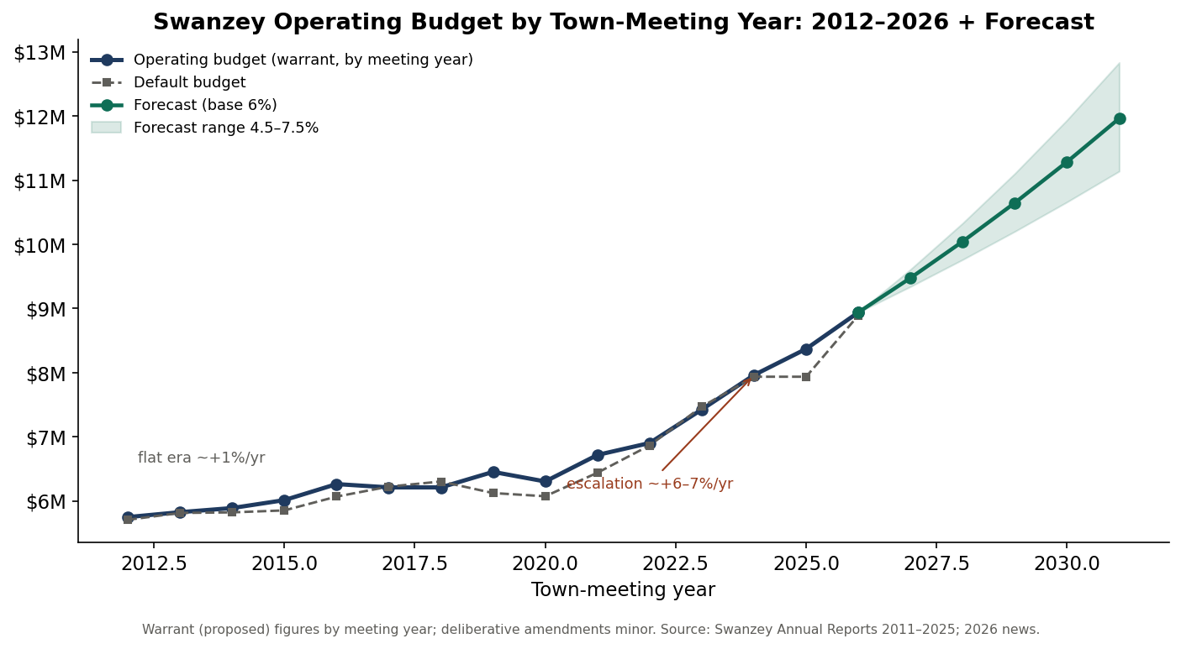
Operating budget by town-meeting year, 2012–2026, with the forecast band (Part II).
Meeting year | Operating (proposed) | Default | Budget % YES
2012 | $5,747,885 | $5,705,757 | 80%
2016 | $6,262,426 | $6,067,144 | 68%
2020 | $6,303,000 | $6,072,735 | —
2023 | $7,425,000 | $7,468,834 | 62%
2025 | $8,370,000 | $7,935,699 | 57%
2026 | $8,939,036 | $8,891,785 | passed

2. How the budget works (and why the 'no' lever is gone)
- Governing law — RSA 32. Appropriation by purpose; no over-expenditure (32:8); transfers within the total (32:10); lapse at year-end (32:7); emergency over-spend needs DRA approval (32:11).
- Forms. MS-636 (proposed) or MS-737 (budget-committee towns, filed within 20 days of the meeting); MS-232 'Appropriations as Voted' filed within 20 days.
- SB2 default budget — RSA 40:13, IX. If the operating article fails, the default budget takes effect. In Swanzey the default now sits within ~$47K of the proposal — and exceeded it in 2017, 2018, and 2023. 'Vote no to save' no longer works.
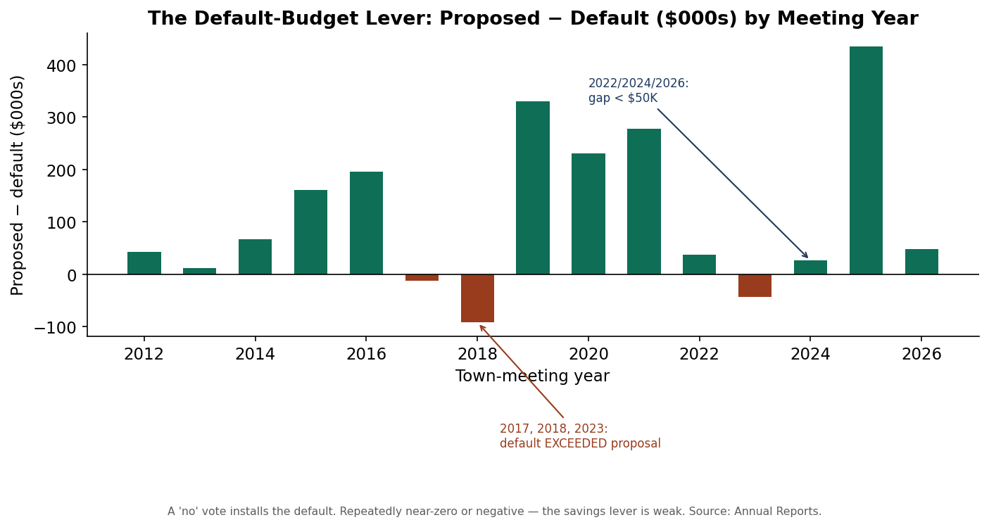
Proposed minus default budget by meeting year — repeatedly near zero or negative.
3. Cost drivers
The climb is structural, not programmatic: health insurance, wages, the NH Retirement System (RSA 100-A) employer rate, and the ambulance/EMS contract. These are largely non-discretionary, so honesty about them — and relentless capture of outside money — is the only durable lever on the municipal share.
4. Tax rate & the 2024 revaluation
Total rate moved $24.51 (2021) → $26.87 (2023) → $19.06 (2024) → $20.18 (2025). The 2024 drop was a revaluation (assessed values rose), not a tax cut. Education is ~60% of the bill; the municipal share the Board controls is ~a quarter.
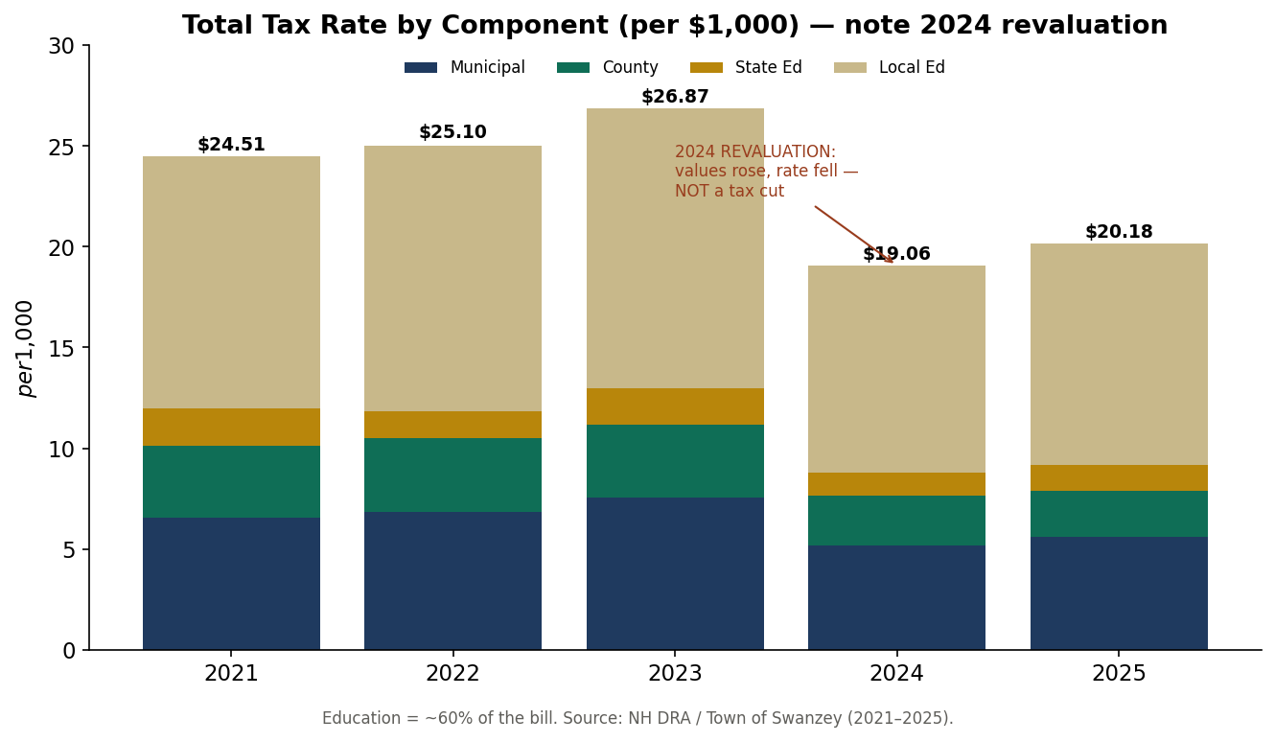
Total tax rate by component, 2021–2025. The 2024 step-down is the revaluation.

PART II — FORECAST
Modeled. Compounds the 2026 adopted budget ($8,939,036) at the observed recent band (low 4.5% / base 6.0% / high 7.5%; recent CAGR ≈ 6.7%). Scenarios, not predictions.
Fiscal year | Low (4.5%) | Base (6.0%) | High (7.5%)
2026 (actual) | $8.94M | $8.94M | $8.94M
2027 | $9.34M | $9.48M | $9.61M
2028 | $9.76M | $10.04M | $10.33M
2029 | $10.20M | $10.65M | $11.10M
2030 | $10.66M | $11.29M | $11.94M
2031 | $11.14M | $11.96M | $12.83M

Base case crosses $10M around 2028 and approaches $12M by 2031 — with no new services, purely on the cost escalators.
Budget-approval risk
Operating-budget support has slid from ~80% (2011–15) to 57% (2025). On trend a budget failure becomes plausible within a few cycles — though, because the default ≈ the proposal, the fiscal consequence is now muted; the real contest moves to special/capital articles.
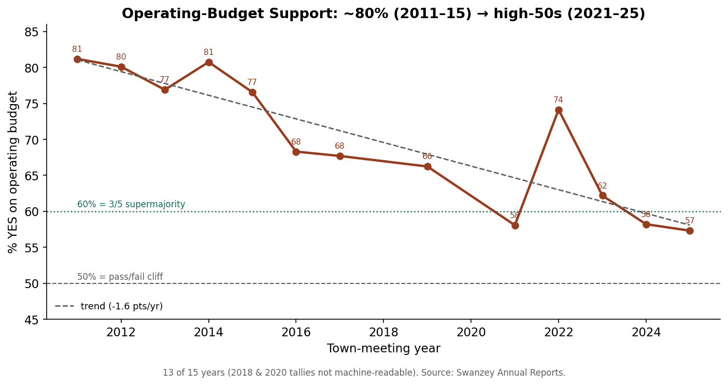
Operating-budget support, 2011–2025, with trend.
Fund-balance guidance. Hold unassigned fund balance in DRA's prudent band (≈ 5–17% of the operating budget). Treat any amount 'applied to reduce taxes' as multi-year smoothing, not a one-year cut — over-applying lowers next year's base and spikes the rate.

PART III — CAPITAL PLAN
5. The backlog and the 3/5 problem
About $5.3M of identified needs: the public-works facility, the Christian Hill Road bridge, Lower Winchester Street, the West Swanzey water system, and Town Hall accessibility. The facility won majorities in 2024 and 2026 but failed the 3/5 a bond requires. Reserves and credits, by contrast, pass 78–90%.
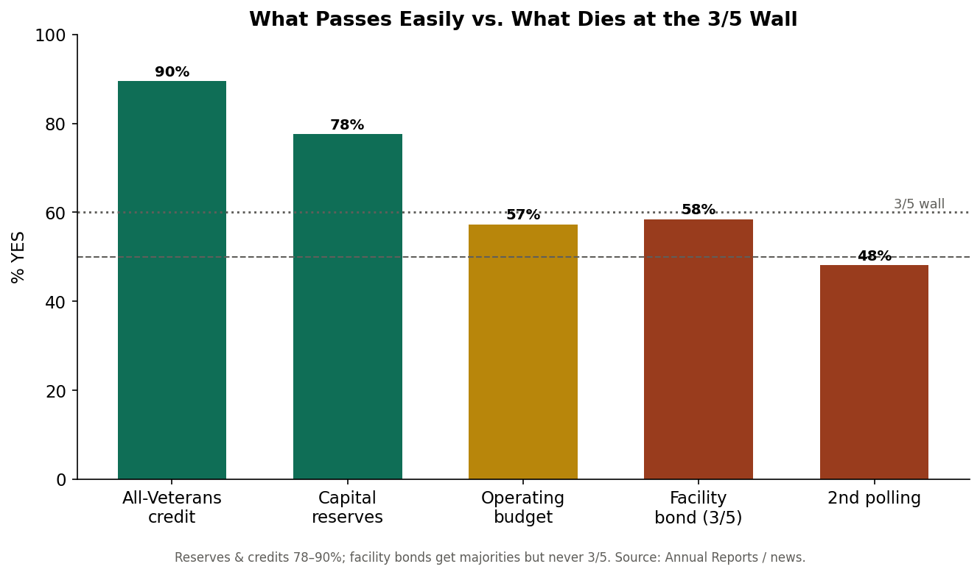
What passes easily versus what dies at the 3/5 wall.
6. The funding strategy — 62% other people's money
Stack outside funding first: 80% state bridge aid (RSA 234) for the bridge; the DWSRF (repaid by water rates, plus principal forgiveness) for water; block grant and CDBG for the street and ADA work. About 62% of the backlog is non-property-tax money, leaving ~$2.0M local — saved via majority-vote reserves, with $0 new bonds.
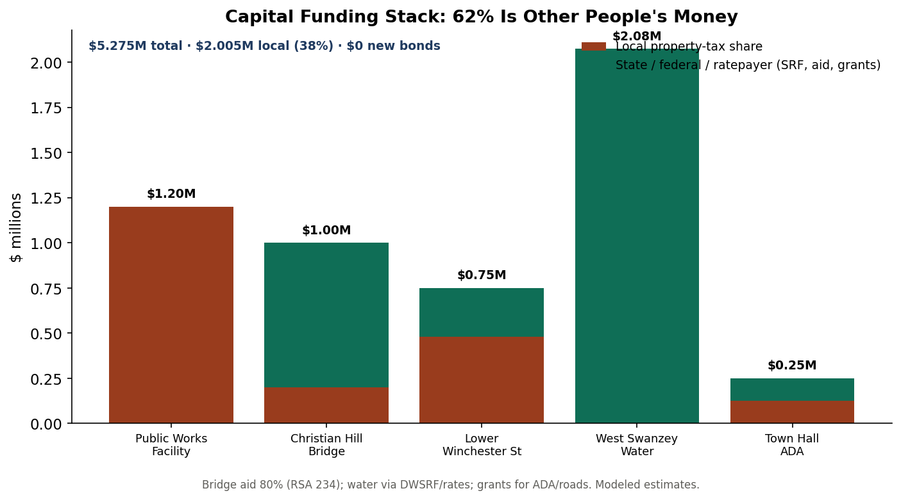
Funding stack by project: most cost carried by aid, water rates, and grants.
Project | Total | Local share | Primary funding path
Public Works Facility | $1.20M | $1.20M | RSA 35 reserve (pay-go ~2031)
Christian Hill Rd Bridge | $1.00M | $0.20M | RSA 234 aid 80% + bridge reserve
Lower Winchester St | $0.75M | $0.48M | Highway block grant + roads reserve
West Swanzey Water | $2.075M | ~$0 (tax) | DWSRF, repaid by water rates + grants
Town Hall ADA | $0.25M | $0.125M | CDBG + facilities reserve
TOTAL | $5.275M | $2.005M (38%) | $0 new bonds

7. The reserve ladder & the tax glide
Capital Reserve Fund | Annual deposit | Funds | Vote
Public Works Facility | $150–300K | the facility | majority
Bridges | $50K | Christian Hill 20% | majority
Highway Reconstruction | $100K | Lower Winchester St | majority
Highway Equipment | $90K | fleet cycle | majority
Fire Apparatus | $70K | engine/tanker cycle | majority
Town Facilities (ADA) | $40K | Town Hall, buildings | majority
Technology & Records | $20K | GIS, cyber, retention | majority

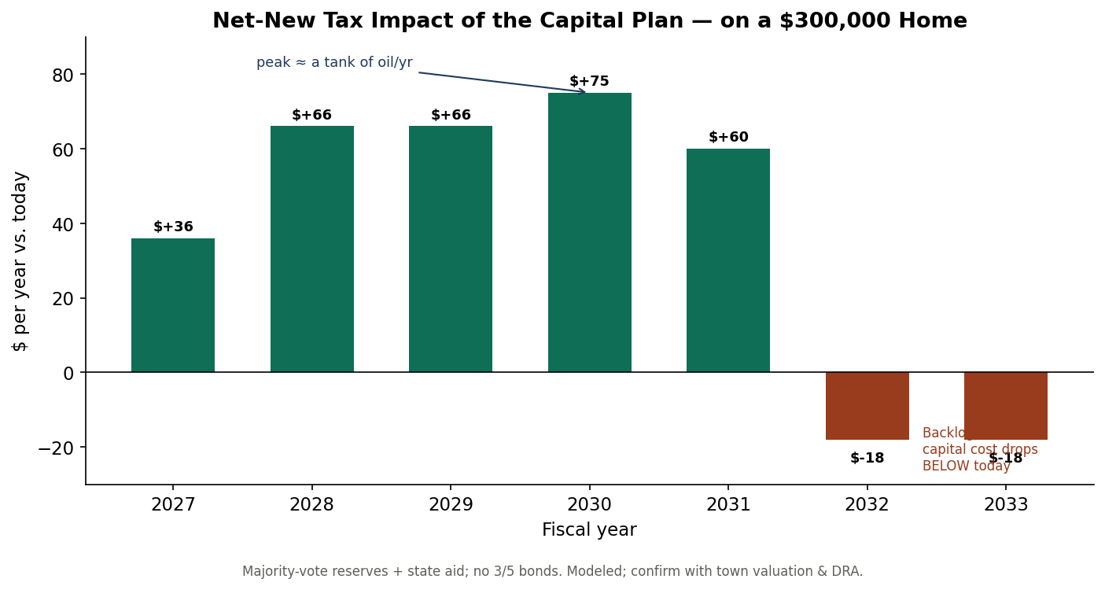
Net-new tax impact on a $300,000 home: peaks ≈ +$75, then below today once built.
8. Decision rules
If the project is… | Use… | Because
≤ ~$250K, recurring | a capital reserve (pay-go) | simple majority, no interest
a town bridge (≥10 ft) | RSA 234 aid + reserve for 20% | state pays 80%
water/sewer | DWSRF, repaid by rates | off the property tax
large, urgent, unavoidable | Bond Bank (RSA 33) — last resort | only when reserves can't get there in time
anything | listed in the published CIP first | surprise becomes expectation

DRA-compliant model warrant articles for the reserve ladder and the bridge-aid / DWSRF / CDBG authorizations are ready in the companion capital-forecast folder.

PART IV — OPERATING PLAYBOOK
9. The first twelve months
Quarter | Moves
Q1 | Stabilize the administrator's office (multi-year agreement + written evaluation). Publish a draft six-year CIP. Issue the one-page tax-bill explainer.
Q2 | Warrant & pass the capital reserve ladder (majority votes). File State Bridge Aid for Christian Hill Rd. Commission the water rate study.
Q3 | Advance DWSRF water financing. Deliver one visible 'small win' (ADA via CDBG + reserve). Adopt operating norms for the five-member board.
Q4 | Bring the full CIP + reserve plan to the deliberative session with an information night. Report the year's progress publicly.

10. The annual municipal cycle
When | What
By Sept 1 | File MS-1 (valuation), MS-434 (revenues), MS-535 (financial report)
Oct–Dec | Build budget & default budget; CIP update; budget public hearing; post warrant (RSA 31:95)
~1st Tue Feb | SB2 deliberative session (debate & amend)
~2nd Tue Mar | SB2 ballot: budget, articles, officer elections
Meeting +20 days | File MS-232 'Appropriations as Voted'
Fall | DRA sets the tax rate; issue tax bills

11. Dashboard — the numbers to watch
Metric | Watch
Operating budget / YoY | ~$8.94M; keep YoY honest about drivers
Budget % YES | 57% (2025) — arrest the slide with transparency
Unassigned fund balance | keep within ~5–17% of operating budget
Reserve balances | grow toward project targets (ladder above)
Next statutory deadline | always know it (MS-1 / MS-232 / hearing / warrant)
Tax rate & valuation | total $20.18 (2025); refresh real MS-1 valuation

Appendix — Provenance & key RSA
Real figures from the Town of Swanzey's annual reports (2011–2025), NH DRA, and local news; capital figures and forecasts are clearly-labeled planning estimates, keyed to town-meeting year (verified against as-voted results for 2020/2023/2025). Key statutes: RSA 32 (budget), 40:13 (SB2/default), 35 (reserves), 33/35-A (bonding/Bond Bank), 234 (bridge aid), 38 (utilities), 162-K (TIF), 674:5-8 (CIP), 91-A (right-to-know), 33-A (records), 165 (welfare), 273-A (labor), 100-A (NHRS). Companion files: Financial Review, Capital Workbook (live model), Strategic Review, and the Interview Workbook.

